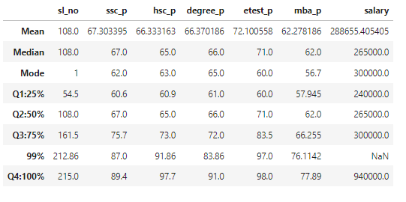

Percentile Analysis Summary

# 1. SSC_P (Secondary School Certificate Percentage)

- Q1:25%: 60.6%  
 - Q2:50% (Median): 67.0%  
 - Difference (Q2 - Q1): +6.4%  
 - Q3:75%: 75.7%  
 - Difference (Q3 - Q2): +8.7%  
 - 99%: 87.0%  
 - Difference (99% - Q3): +11.3%  
 - Q4:100%: 89.4%  
 - Difference (Q4 - 99%): +2.4%

**Summary**: SSC_P increases by 6.4% from Q1 to Q2, by 8.7% from Q2 to Q3, and by 11.3% from Q3 to the 99th percentile. There is a smaller rise of 2.4% from the 99th percentile to the maximum (Q4:100%).

# 2. HSC_P (Higher Secondary Certificate Percentage)

- Q1:25%: 60.9%  
 - Q2:50% (Median): 65.0%  
 - Difference (Q2 - Q1): +4.1%  
 - Q3:75%: 73.0%  
 - Difference (Q3 - Q2): +8.0%  
 - 99%: 91.86%  
 - Difference (99% - Q3): +18.86%  
 - Q4:100%: 97.7%  
 - Difference (Q4 - 99%): +5.84%

**Summary**: HSC_P increases by 5.0% from Q1 to Q2, by 8.0% from Q2 to Q3, and by a significant 18.86% from Q3 to the 99th percentile. The rise between the 99th percentile and Q4 is 5.84%.

# 3. Degree_P (Degree Percentage)

- Q1:25%: 61.0%  
 - Q2:50% (Median): 66.0%  
 - Difference (Q2 - Q1): +5.0%  
 - Q3:75%: 72.0%  
 - Difference (Q3 - Q2): +6.0%  
 - 99%: 83.86%  
 - Difference (99% - Q3): +11.86%  
 - Q4:100%: 91.0%  
 - Difference (Q4 - 99%): +7.14%

**Summary**: Degree_P shows consistent increases of 6.0% between Q1 to Q2 and Q2 to Q3, with a larger 11.86% jump between Q3 and the 99th percentile. The final rise between the 99th percentile and Q4 is 7.14%.

# 4. ETest_P (Entrance Test Percentage)

- Q1:25%: 60.0%  
 - Q2:50% (Median): 71.0%  
 - Difference (Q2 - Q1): +11.0%  
 - Q3:75%: 72.0%  
 - Difference (Q3 - Q2): +1.0%  
 - 99%: 97.0%  
 - Difference (99% - Q3): +25.0%  
 - Q4:100%: 98.0%  
 - Difference (Q4 - 99%): +1.0%

**Summary**: ETest_P shows an 11.0% increase from Q1 to Q2, a small 1.0% rise from Q2 to Q3, and a large jump of 25.0% from Q3 to the 99th percentile. The increase between the 99th percentile and Q4 is minimal at 1.0%.

# 5. MBA_P (MBA Percentage)

- Q1:25%: 57.945%  
 - Q2:50% (Median): 62.0%  
 - Difference (Q2 - Q1): +4.055%  
 - Q3:75%: 66.255%  
 - Difference (Q3 - Q2): +4.255%  
 - 99%: 76.1142%  
 - Difference (99% - Q3): +9.8592%  
 - Q4:100%: 77.89%  
 - Difference (Q4 - 99%): +1.7758%

**Summary**: MBA_P shows moderate increases of around 4.0% between Q1 to Q2 and Q2 to Q3, with a larger 9.86% rise from Q3 to the 99th percentile. The final increase from the 99th percentile to Q4 is 1.78%.

# 6. Salary

- Q1:25%: ₹240,000  
 - Q2:50% (Median): ₹265,000  
 - Difference (Q2 - Q1): +₹25,000  
 - Q3:75%: ₹300,000  
 - Difference (Q3 - Q2): +₹35,000  
 - 99%: ₹940,000  
 - Difference (99% - Q3): +₹640,000  
 - Q4:100%: ₹940,000  
 - Difference (Q4 - 99%): ₹0 (Same as 99%)

**Summary**: Salary shows moderate increases of ₹25,000 from Q1 to Q2, and ₹35,000 from Q2 to Q3, followed by a dramatic jump of ₹640,000 from Q3 to the 99th percentile. There is no difference between the 99th percentile and Q4.